Practical:3.3
Aim
To create an interactive Android application that uses fragments to divide the screen into multiple sections, allowing users to input data in one fragment and display it in another fragment dynamically.
Problem Statement
Develop an Android application containing two fragments inside one activity:
- Input Fragment: Accepts user input (e.g., name, message)
- Display Fragment: Shows the entered input in real-time when a button is clicked.
This demonstrates fragment interaction, dynamic UI updates, and fragment lifecycle understanding.
Open Android Studio → New Project
Select Empty Views Activity
Project Configuration:
Name: FragmentCommunicationApp
Package: com.example.fragmentsapp
Language: Java
Minimum SDK: API 21
Finish and wait for Gradle sync.
STEP 2: Create Two Fragments
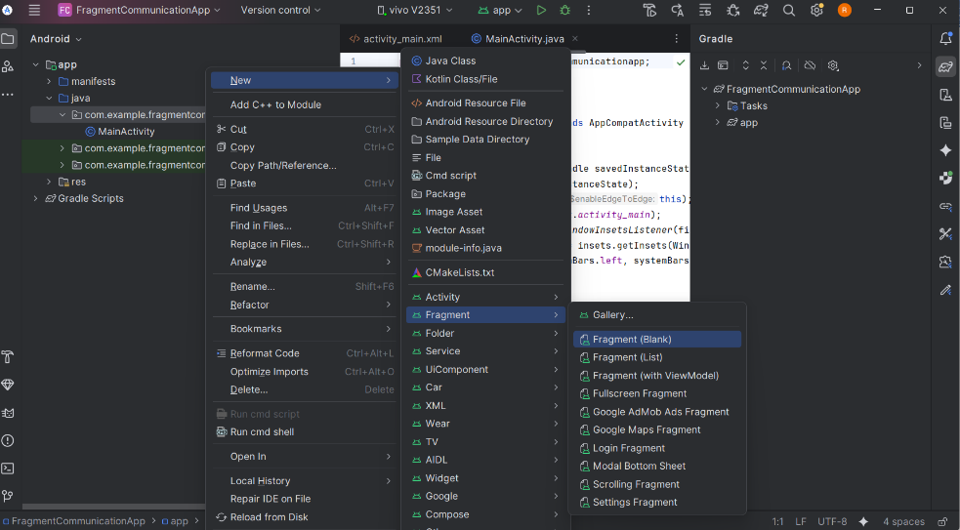

Fragment A (Input Fragment)
- Right-click java → New → Fragment → Fragment (Blank)
- Name: InputFragment
- Layout: fragment_input.xml
- Finish
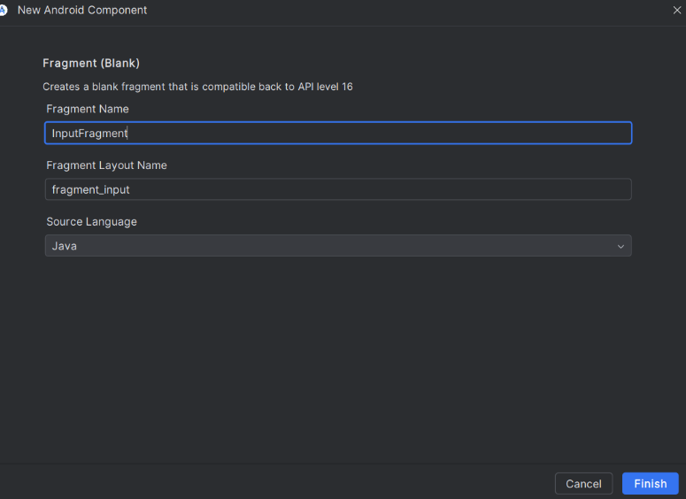
Fragment B (Display Fragment)
- Right-click java → New → Fragment → Fragment (Blank)
- Name: DisplayFragment
- Layout: fragment_display.xml
- Finish
STEP 3: Design Fragment Layouts
3A: fragment_input.xml (User Input)
<LinearLayout xmlns:android="http://schemas.android.com/apk/res/android"
android:layout_width="match_parent"
android:layout_height="match_parent"
android:orientation="vertical"
android:padding="24dp"
android:gravity="center">
<EditText
android:id="@+id/etMessage"
android:layout_width="match_parent"
android:layout_height="wrap_content"
android:hint="Enter your message" />
<Button
android:id="@+id/btnSend"
android:layout_width="wrap_content"
android:layout_height="wrap_content"
android:text="Send"
android:layout_marginTop="16dp" />
</LinearLayout>
3B: fragment_display.xml (Display Output)
<LinearLayout xmlns:android="http://schemas.android.com/apk/res/android"
android:layout_width="match_parent"
android:layout_height="match_parent"
android:gravity="center"
android:padding="24dp">
<TextView
android:id="@+id/tvDisplay"
android:layout_width="wrap_content"
android:layout_height="wrap_content"
android:text="Your message will appear here"
android:textSize="20sp"
android:textStyle="bold" />
</LinearLayout>
STEP 4: Add Fragments to MainActivity Layout
Open activity_main.xml and replace with:
<LinearLayout xmlns:android="http://schemas.android.com/apk/res/android"
android:orientation="horizontal"
android:layout_width="match_parent"
android:layout_height="match_parent">
<FrameLayout
android:id="@+id/fragment_container_input"
android:layout_width="0dp"
android:layout_weight="1"
android:layout_height="match_parent"/>
<FrameLayout
android:id="@+id/fragment_container_display"
android:layout_width="0dp"
android:layout_weight="1"
android:layout_height="match_parent"/>
</LinearLayout>
Logic:
- Two FrameLayouts divide the screen into left (input) and right (display).
- Fragments will be loaded dynamically into these containers.
STEP 5: Write Java Code for Fragments
5A: InputFragment.java
package com.example.fragmentcommunicationapp;
import android.content.Context;
import android.os.Bundle;
import android.view.LayoutInflater;
import android.view.View;
import android.view.ViewGroup;
import android.widget.Button;
import android.widget.EditText;
import androidx.fragment.app.Fragment;
public class InputFragment extends Fragment {
EditText etMessage;
Button btnSend;
OnMessageSendListener listener;
public interface OnMessageSendListener {
void onMessageSend(String message);
}
@Override
public void onAttach(Context context) {
super.onAttach(context);
if(context instanceof OnMessageSendListener){
listener = (OnMessageSendListener) context;
} else {
throw new RuntimeException(context.toString() + " must implement OnMessageSendListener");
}
}
@Override
public View onCreateView(LayoutInflater inflater, ViewGroup container,
Bundle savedInstanceState) {
View view = inflater.inflate(R.layout.fragment_input, container, false);
etMessage = view.findViewById(R.id.etMessage);
btnSend = view.findViewById(R.id.btnSend);
btnSend.setOnClickListener(new View.OnClickListener() {
@Override
public void onClick(View v) {
String message = etMessage.getText().toString();
listener.onMessageSend(message);
}
});
return view;
}
}
5B: DisplayFragment.java
package com.example.fragmentcommunicationapp;
import android.os.Bundle;
import android.view.LayoutInflater;
import android.view.View;
import android.view.ViewGroup;
import android.widget.TextView;
import androidx.fragment.app.Fragment;
public class DisplayFragment extends Fragment {
TextView tvDisplay;
@Override
public View onCreateView(LayoutInflater inflater, ViewGroup container,
Bundle savedInstanceState) {
View view = inflater.inflate(R.layout.fragment_display, container, false);
tvDisplay = view.findViewById(R.id.tvDisplay);
return view;
}
public void updateMessage(String message){
tvDisplay.setText(message);
}
}
STEP 6: MainActivity.java (Handles Fragment Communication)
package com.example.fragmentcommunicationapp;
import android.os.Bundle;
import androidx.appcompat.app.AppCompatActivity;
import androidx.fragment.app.FragmentManager;
import androidx.fragment.app.FragmentTransaction;
public class MainActivity extends AppCompatActivity implements InputFragment.OnMessageSendListener {
DisplayFragment displayFragment;
@Override
protected void onCreate(Bundle savedInstanceState) {
super.onCreate(savedInstanceState);
setContentView(R.layout.activity_main);
InputFragment inputFragment = new InputFragment();
displayFragment = new DisplayFragment();
FragmentManager fm = getSupportFragmentManager();
FragmentTransaction ft = fm.beginTransaction();
ft.replace(R.id.fragment_container_input, inputFragment);
ft.replace(R.id.fragment_container_display, displayFragment);
ft.commit();
}
@Override
public void onMessageSend(String message) {
displayFragment.updateMessage(message);
}
}
run

